

**Sop for WSUS Patch management process**

**Document Information**

|  |  |  |  |  |  |
| --- | --- | --- | --- | --- | --- |
| **S.No** | **Version No.** | **Prepared By** | **Approved By** | **Date & Month** | **Description** |
| **1** | **1.0** | **Thameem** |  | **21-12-2017** | **Draft version** |
|  |  |  |  |  |  |

|  |  |
| --- | --- |
| **Document Name :** Patch management process | |
| **Project :** TVS & Sons Pvt Ltd | |
| **Subject**: Patch management process | |
| **Document No.:** | **Version :** 1.0 |
| **Prepared by: Thameem, Precision Infomatic** | Date : 21-12-2017 |
| **Reviewed by:** | Date : |

Table of Contents

1.0 Purpose 3

2.0 Responsibility 3

3.0 PROCEDURE WSUS Patch 4

# 1.0 Purpose

This document describes the step by step procedures for WSUS Patch management process.

# 2.0 Responsibility

It is the responsibility of the Datacenter Administrator to Update Patch in all windows servers.

**PROCEDURE FOR WSUS PATCH MANAGEMENT PROCESS**

1. On your Server, open Server Manager, on the Dashboard, click Add Roles and Features then click next 3 times till you get Select server roles box, in Select server roles box, select the **Windows Server Update Services** (In the pop-up window, click Add Features)… then click **Next**…

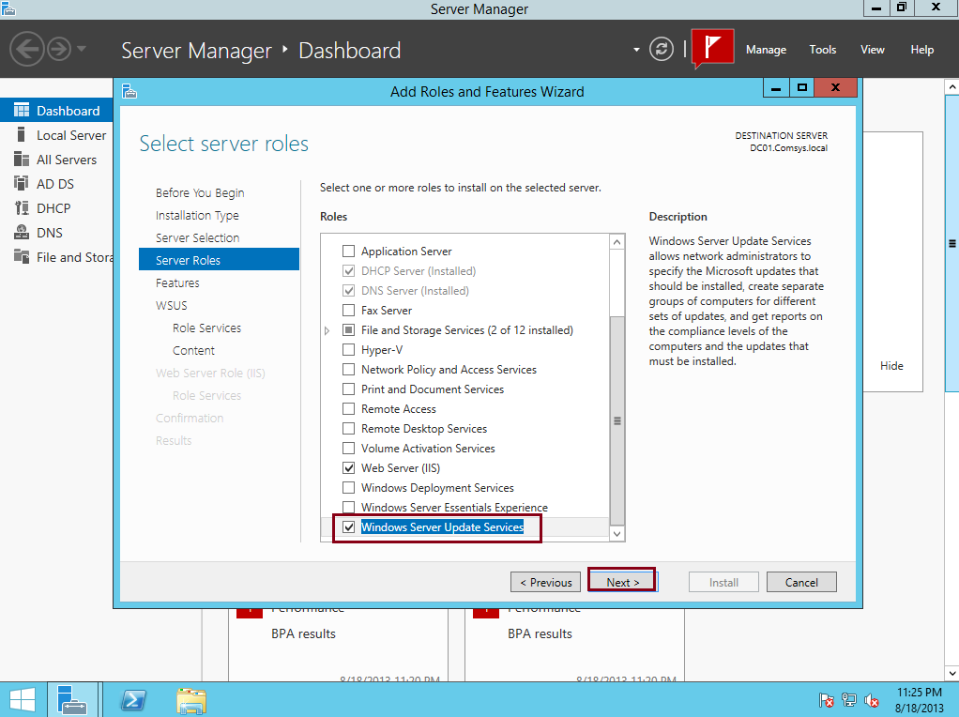

2. On the **Select features** box, click Next…

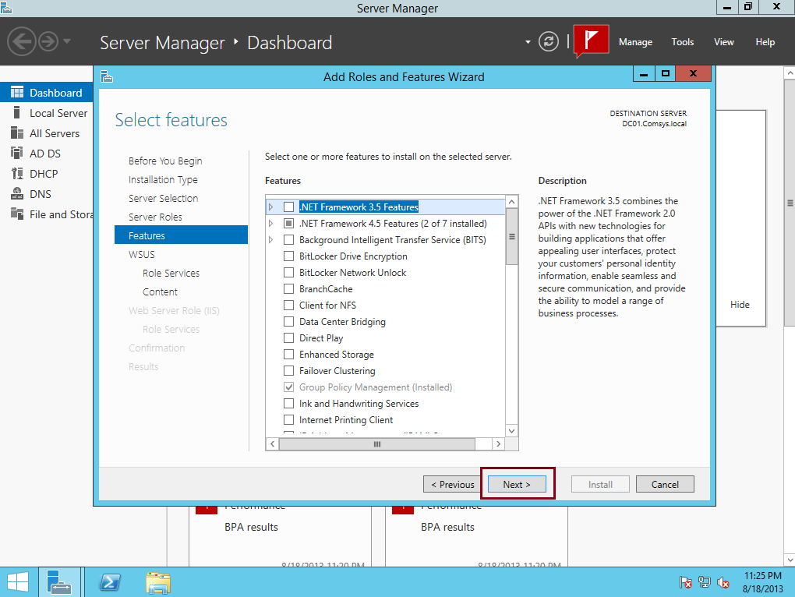

3. On the **Windows Server Update Services** box, click next…

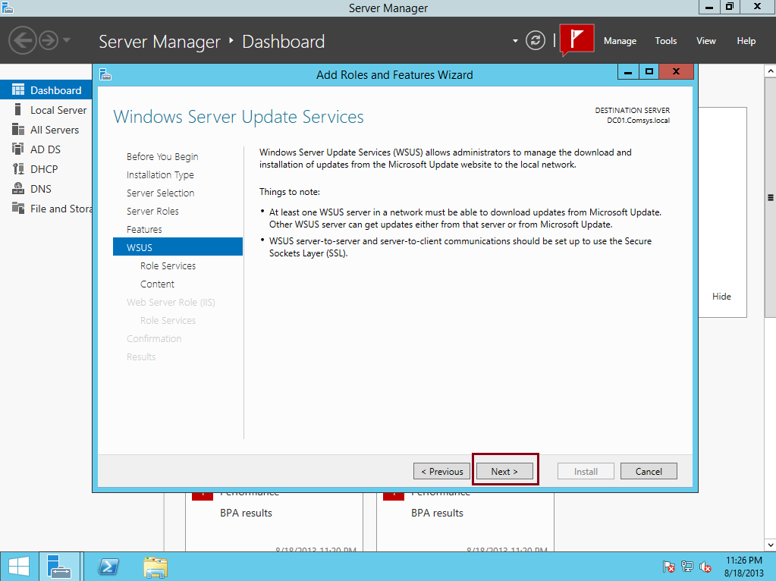

4.  On the Select role services box, verify that both **WID Database** and **WSUS Services** are selected, and then click **next**…

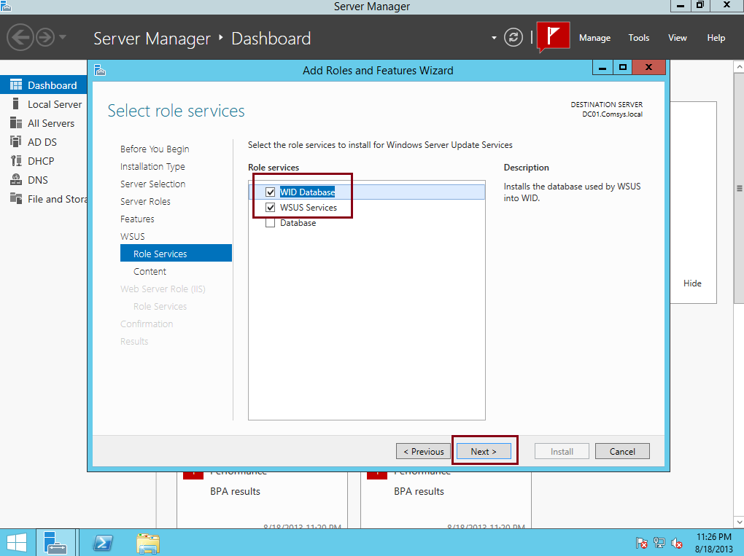

5.  On the Content location selection box, type**C:\Comsys WSUS**, and then click **Next** …

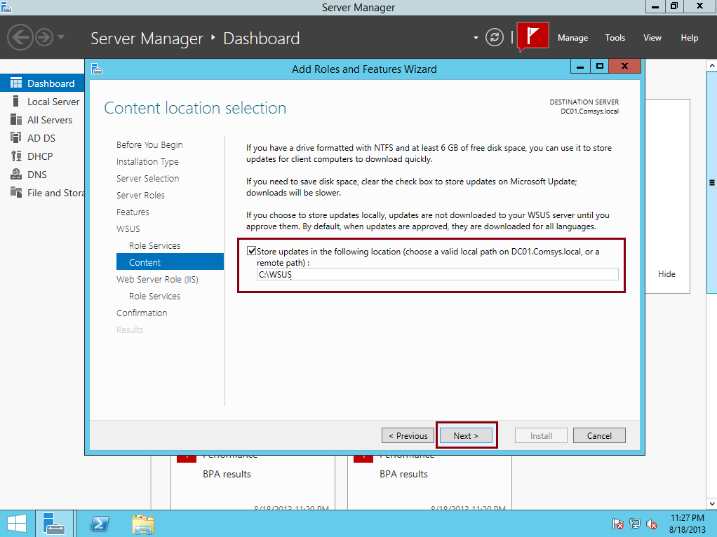

6.  On the **Web Server Role (IIS)** box, click Next …

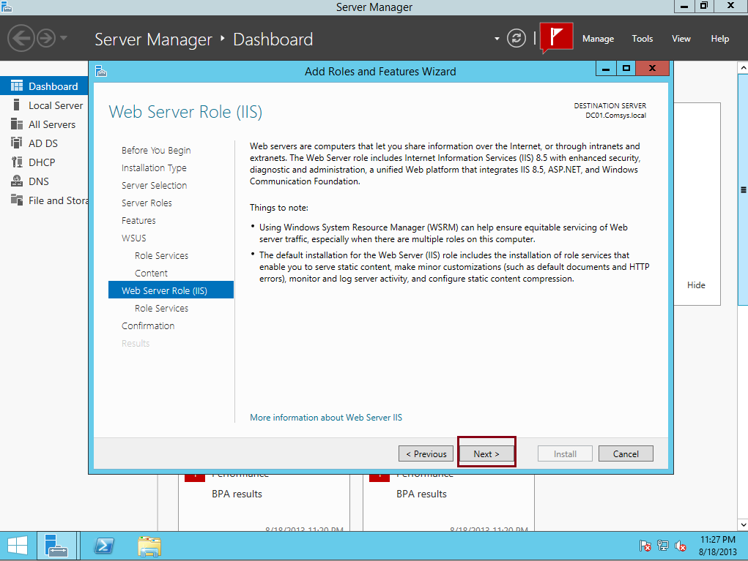

7 .  On the **Select role services** box, click Next …

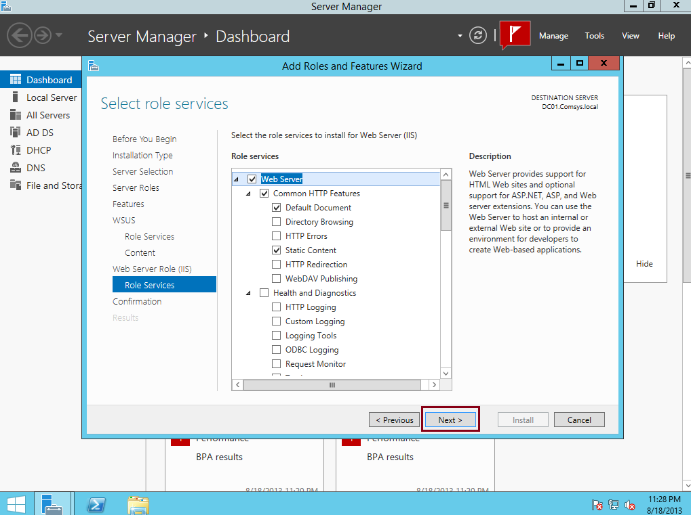

8 .  On the **Confirm installation** selections box, click Install…

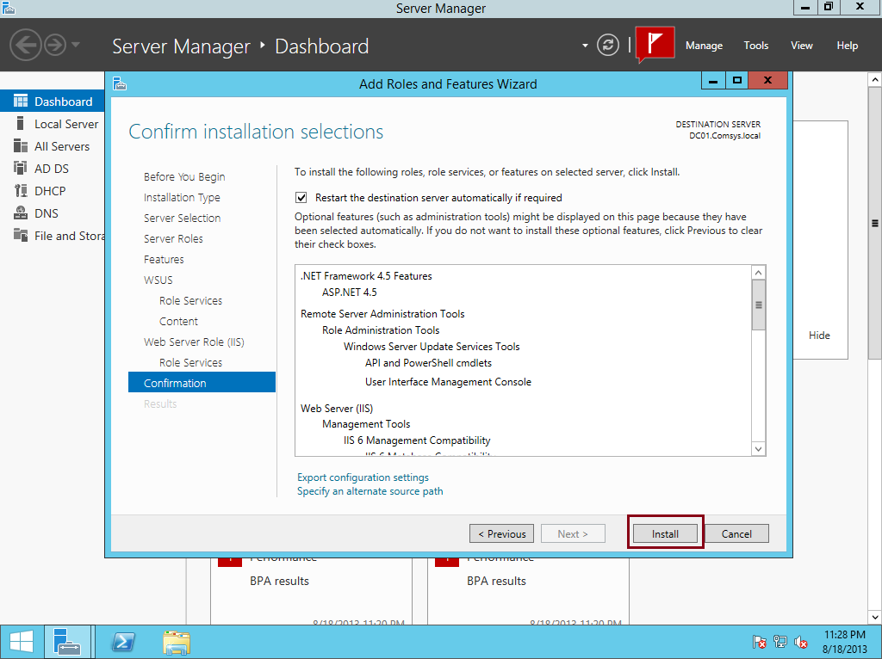

9.  When the installation completes, click **Close**…

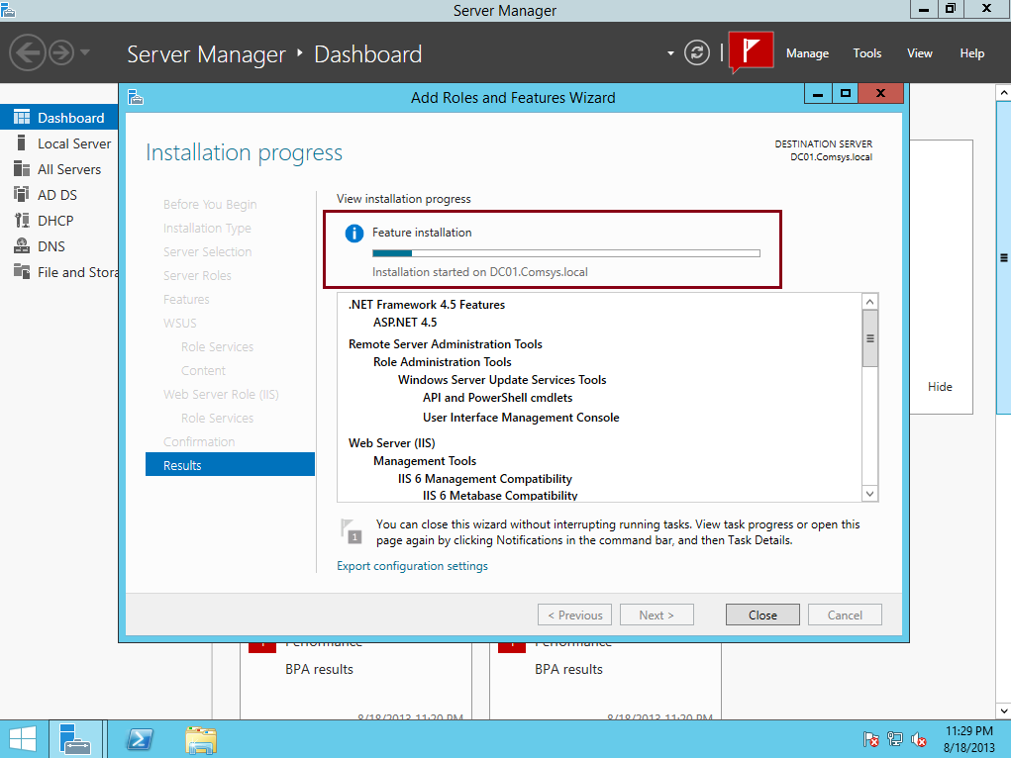

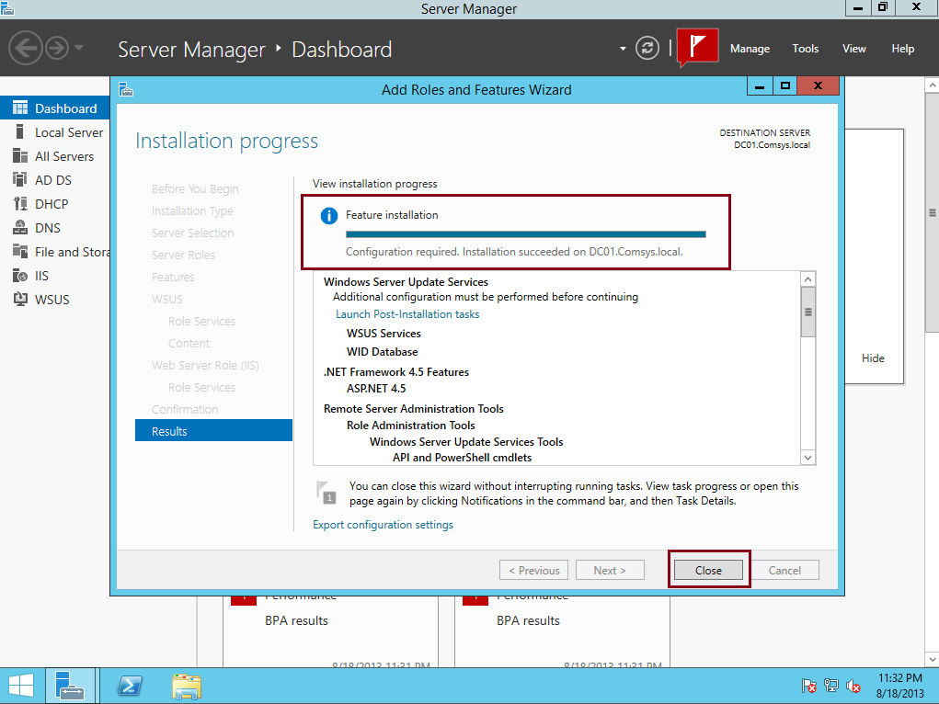

10 . Open Windows Server Update Services console, in the Complete WSUS Installation window, click **Run**, and wait for the task to complete then click Close…

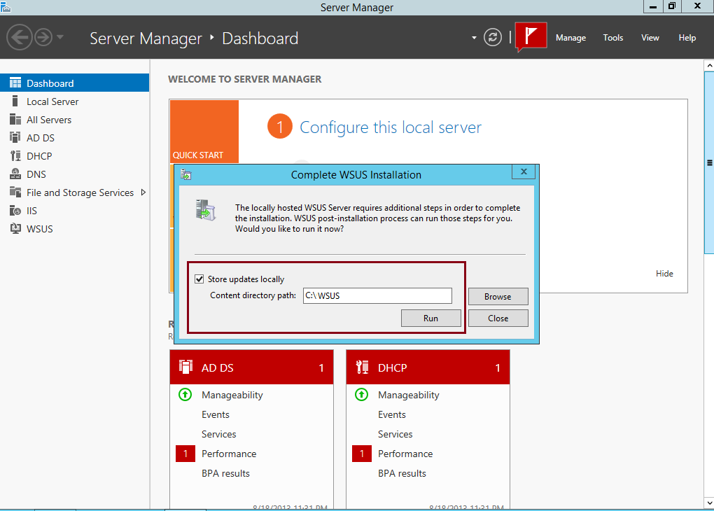

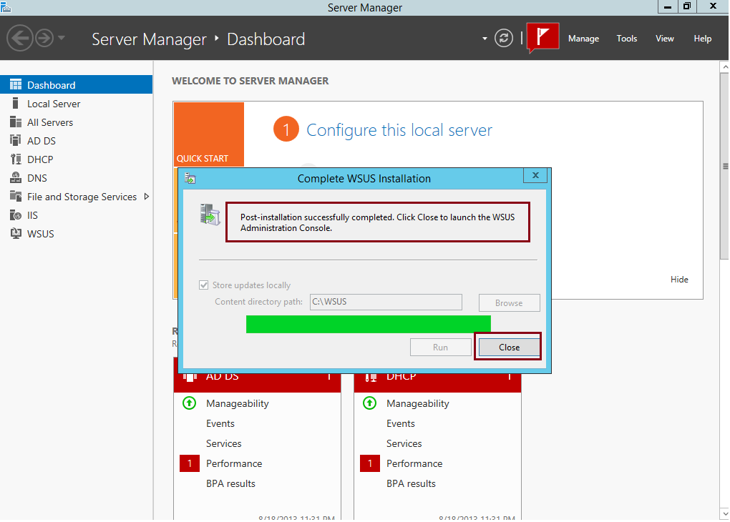

We had successfully installed WSUS , our next task is to **configure WSUS to synchronize with Windows Updates…**

11.  In the Windows Server Update Services Configuration Wizard window, on the Before You Begin, click Next to proceed…

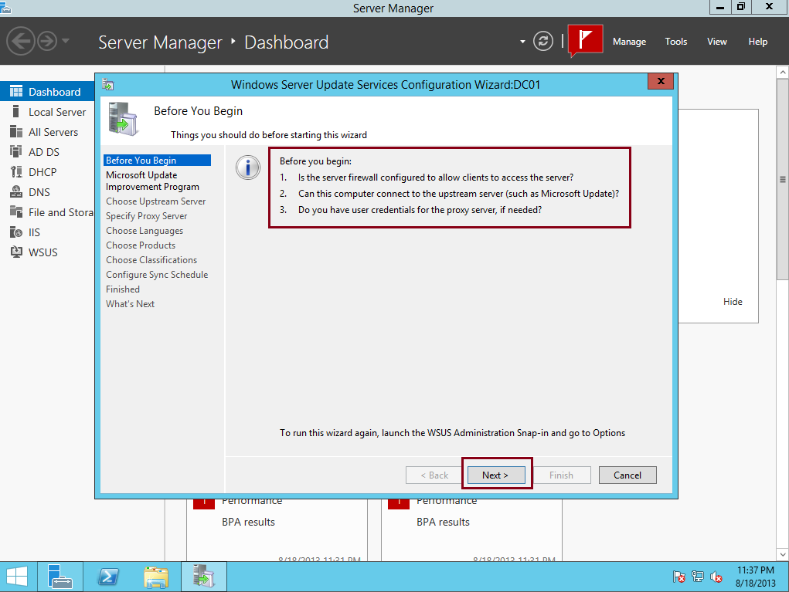

12. On the Join the Microsoft Update Improvement Program, just click Next…

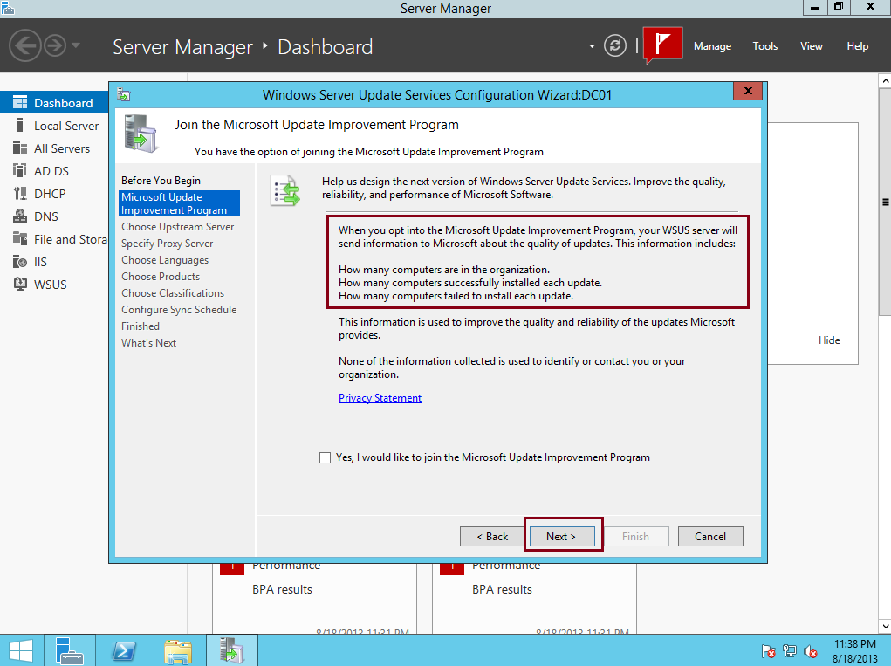

13.  On the Choose Upstream Server box, click the **Synchronize from Microsoft Update** option and then click Next…

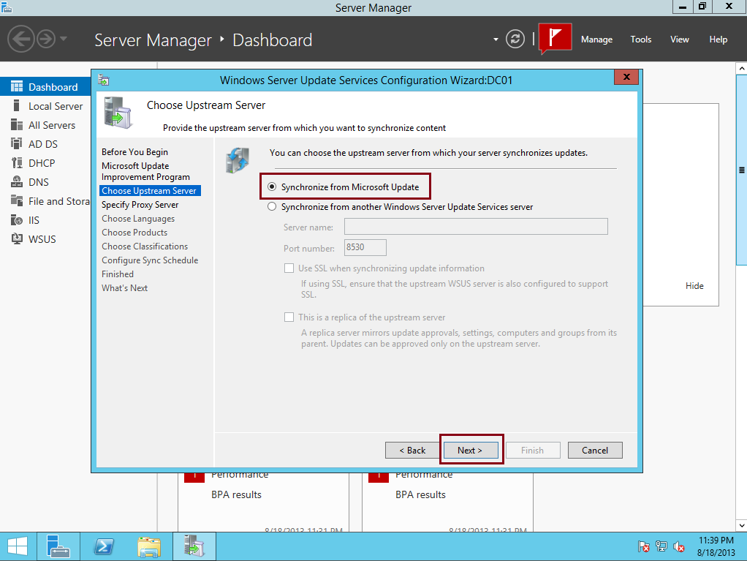

14.  On the Specify Proxy Server box, click **Next**…

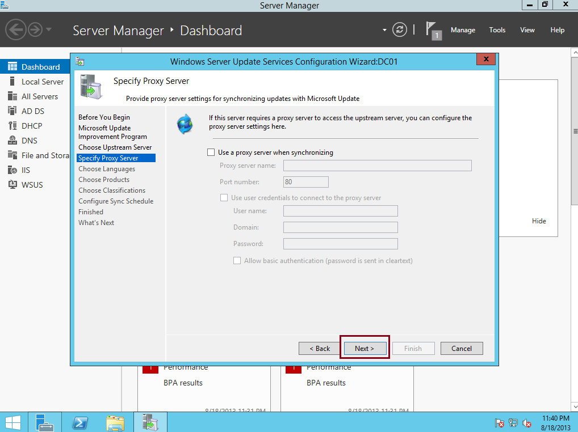

15.  On the Connect to Upstream Server box, click **Start Connecting**. Wait for the Windows Update to be applied, and then click Next…

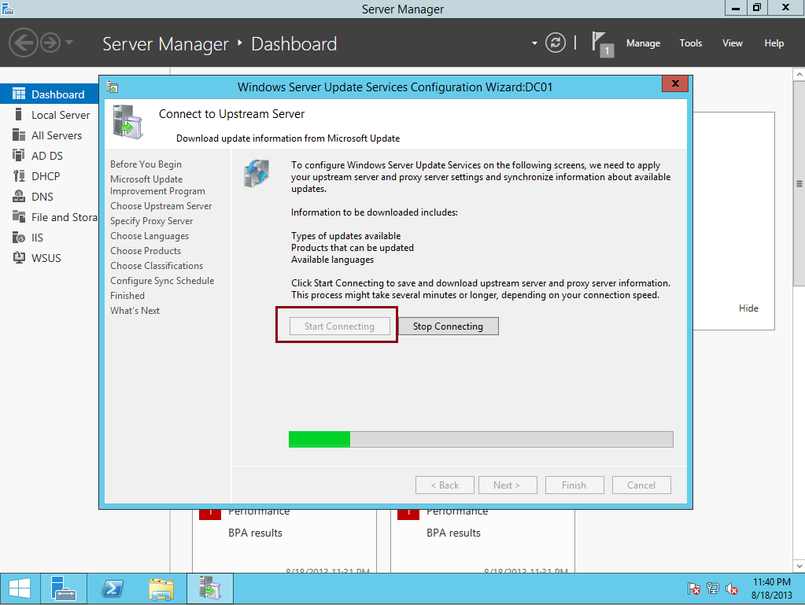

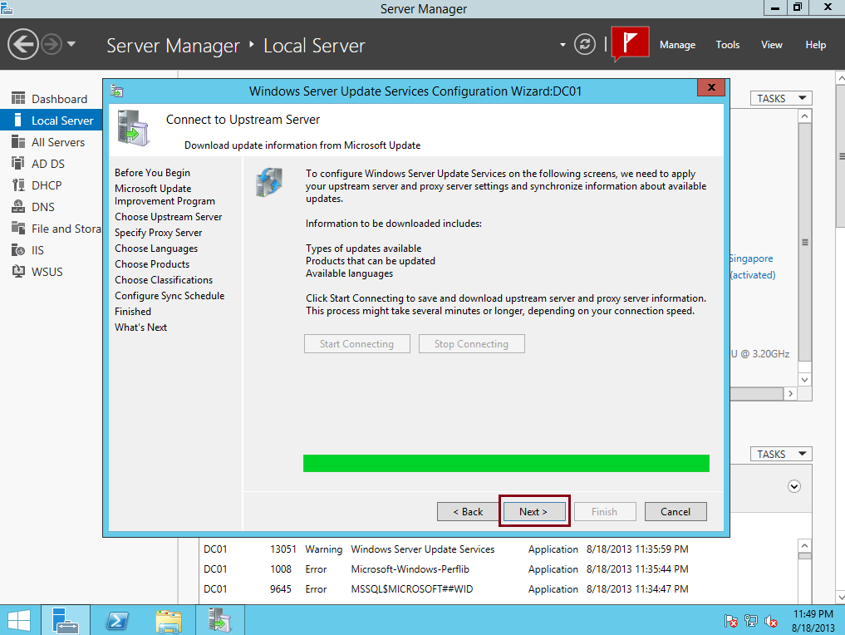

16.  On the Choose **Languages** box, click Next…

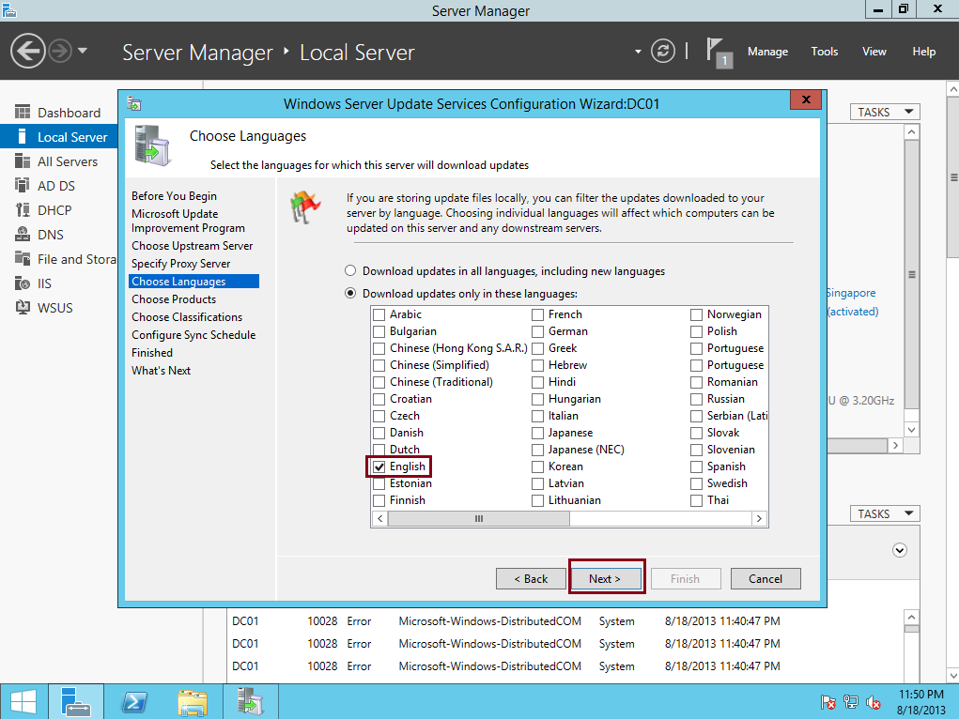

17.  On the Choose **Products** box, choose required product (you can use any Updates follow by you existing application), and click Next…

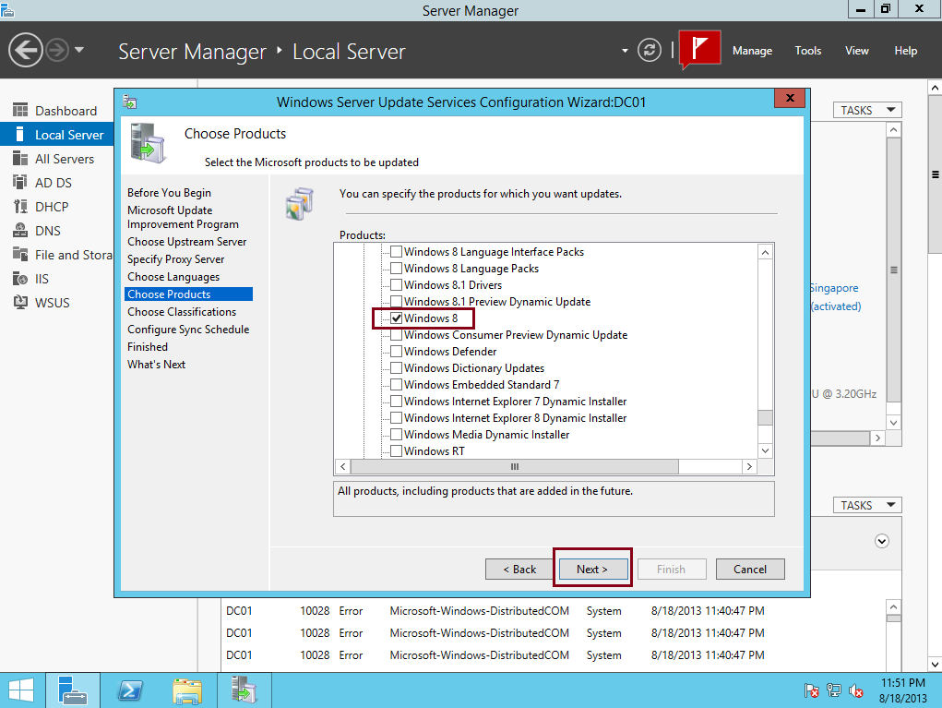

18.  On the Choose Classifications box, I choose **Critical Updates** (you can choose all updates classification if you require and your internet is fast) click Next…

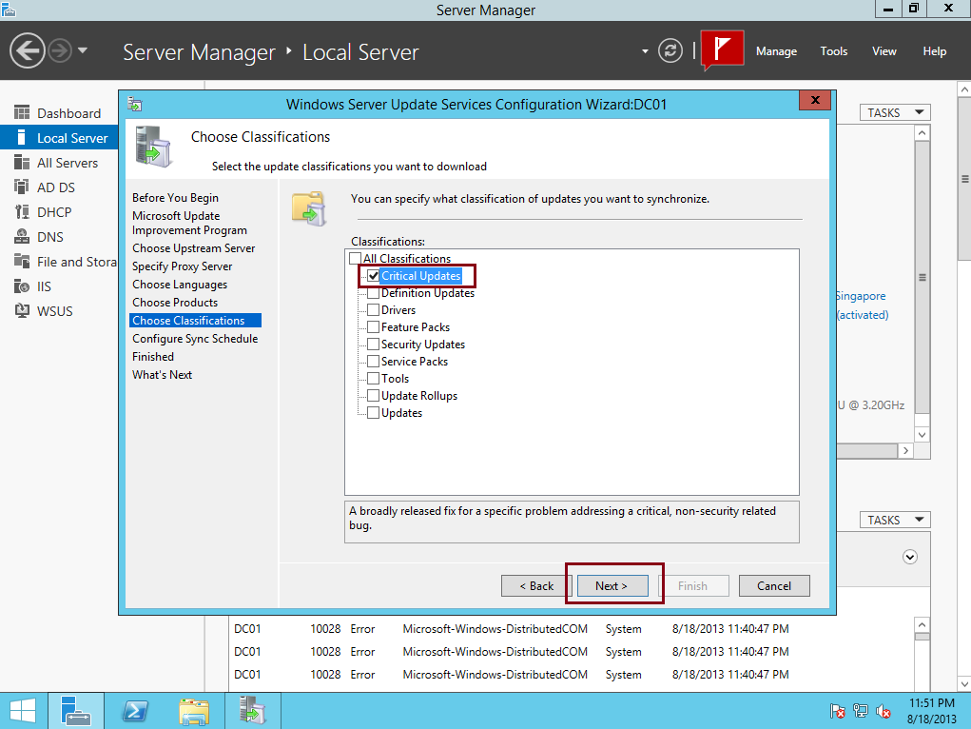

19 .  On the Set Sync Schedule box, I choose **Synchronize manually**, then click Next…

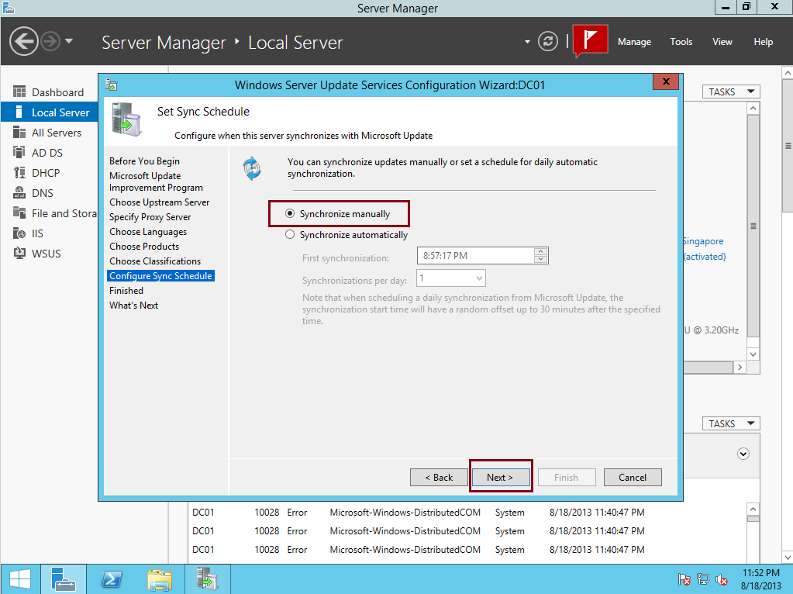

20.  On the Finished box, click the**Begin initial synchronization** option, and then click Finish…

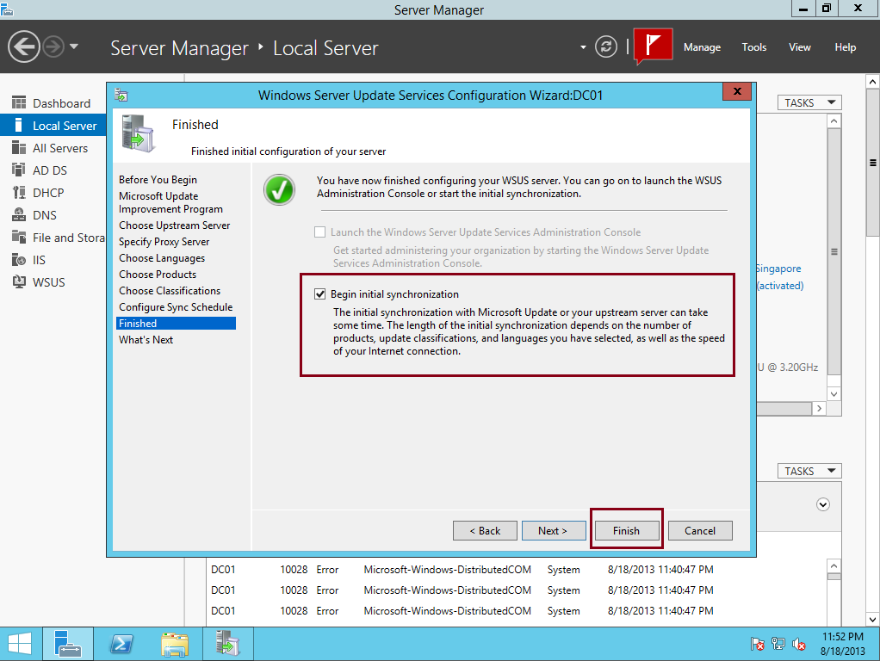

21.  In the Windows Server Update Services console, in the navigation pane, double-click TVS-INF-NSMON1, and please spend few minutes to **reviews** what you had on the WSUS consoles and the information, If you notice in my WSUS Server, WSUS is synchronizing update information, this might take few minutes…

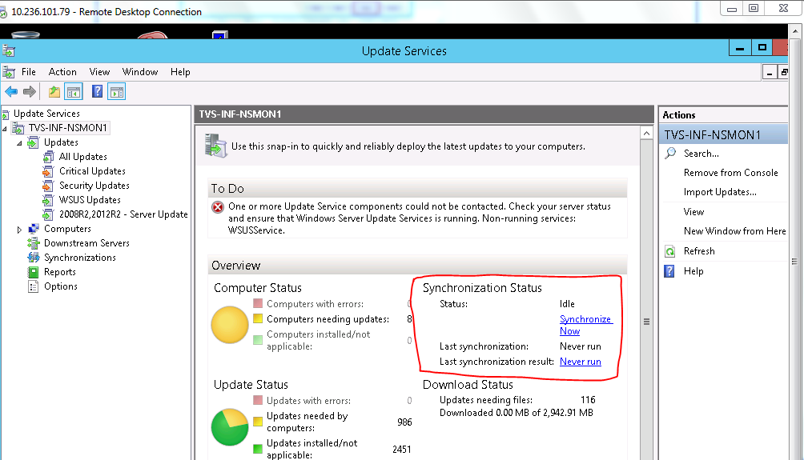

** If everything goes well, on the synchronization status you can see that Status is Idle and the **Last Synchronization result: Succeeded…**

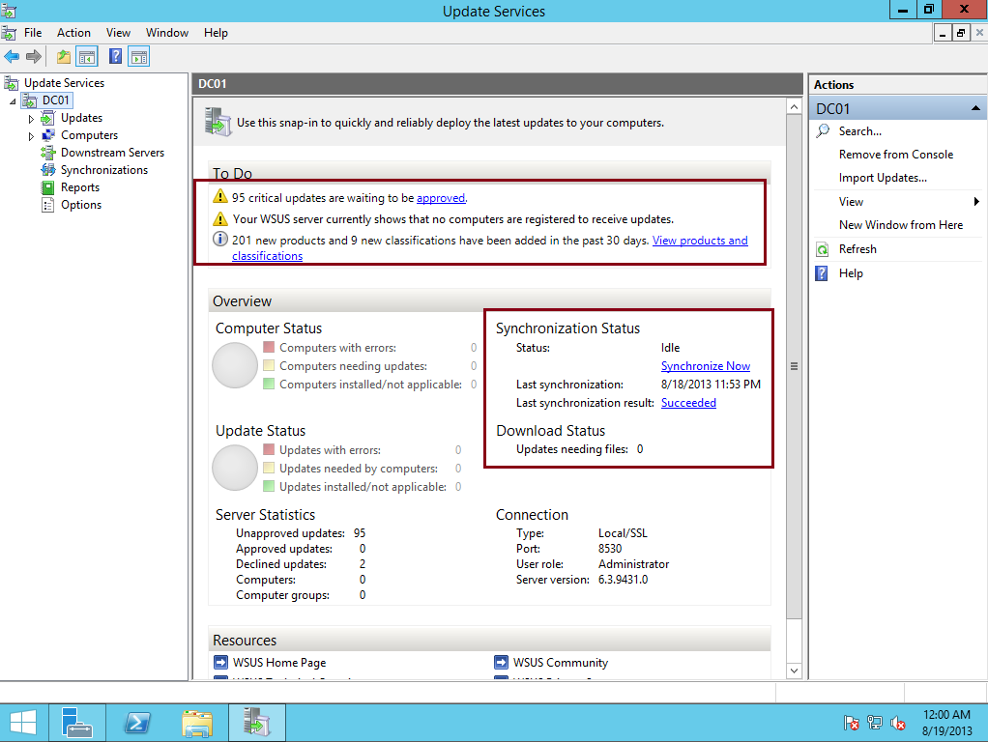

22. Next, let’s **add Computer Group to WSUS**, this method is to make sure that any computer listed in the Computer Group will get the Updates from WSUS Server, On the WSUS console, click **Options** and then double click **Computers.**

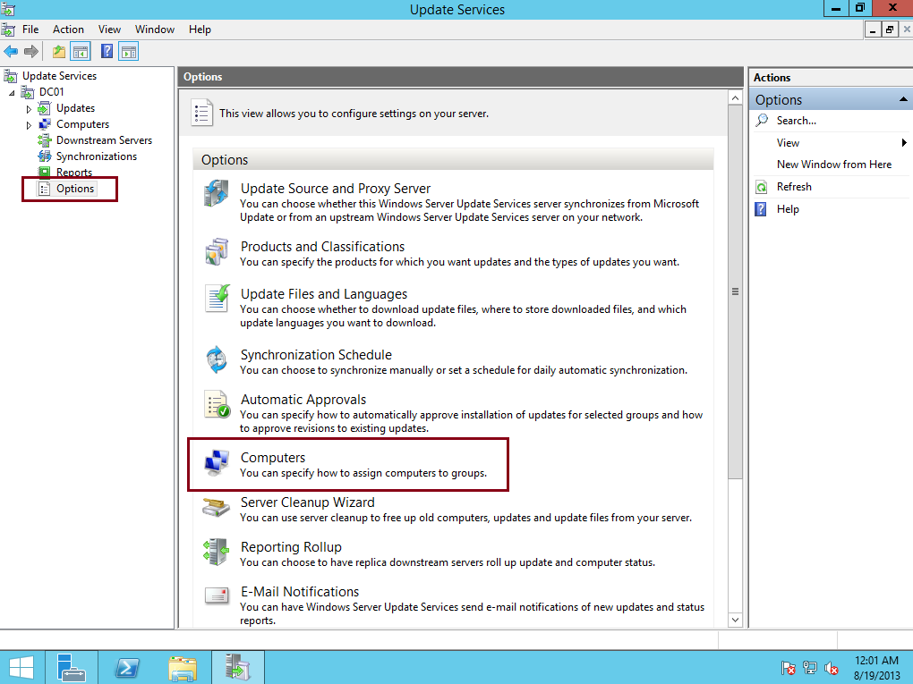

23. In the Computers dialog box, select **Use Group Policy or registry settings on computers then click OK,** 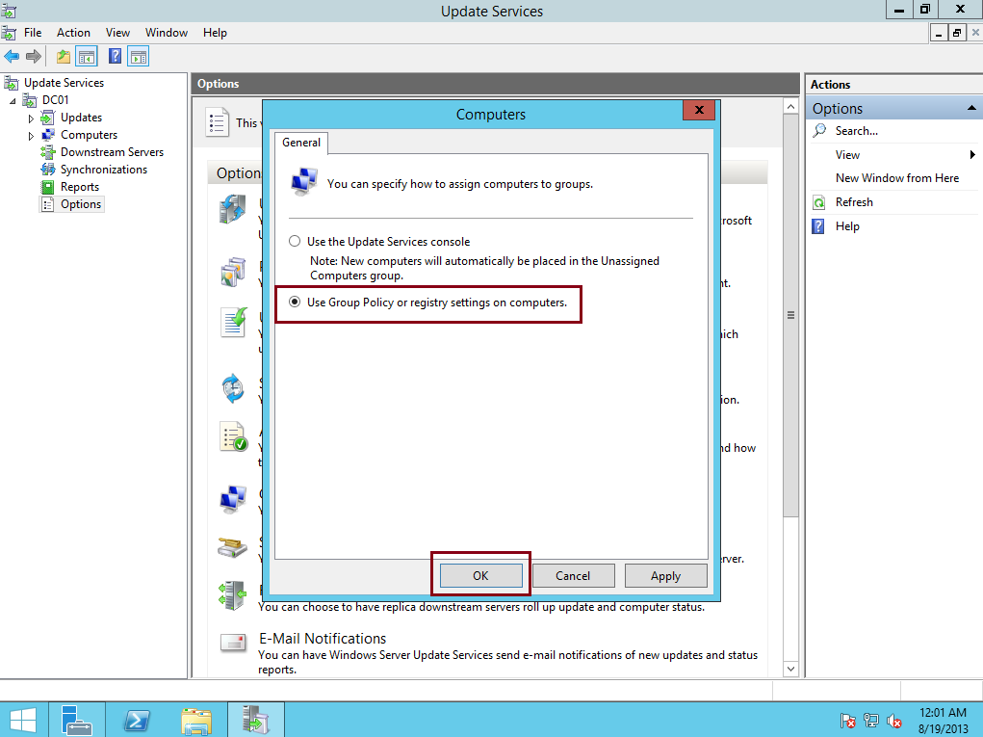

24. Next, click All Computers, and then, in the Actions pane, click **Add Computer Group…**

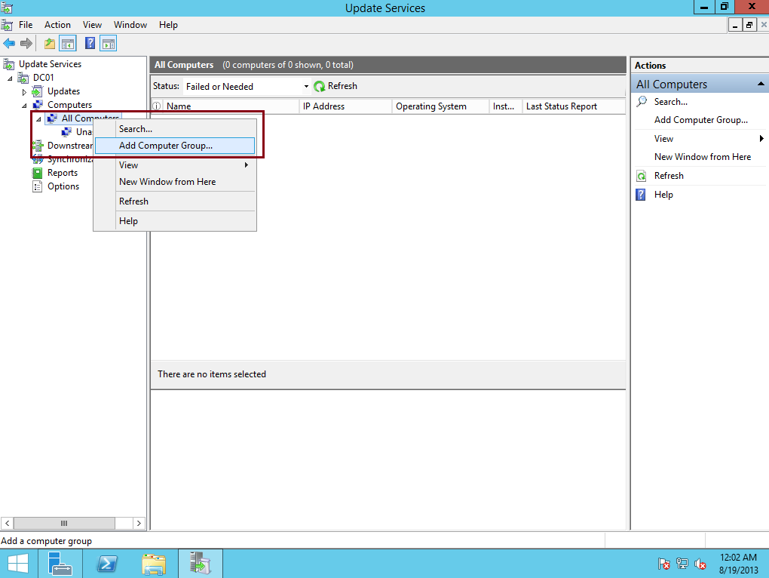

25.  In the Add Computer Group dialog box, in the Name text box, type **Server Group Name as Phase1, Phase2, Phase3 and then click Add…**

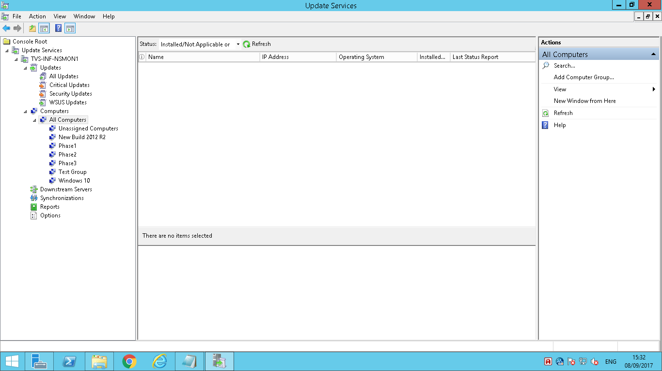

26. Once you successfully add a New Computer Group to WSUS, now we need to **create new GPO and configure it so that all our clients will be effected by this GPO to get the Windows Updates,** On the Domain Server, open Group Policy Management, right click domain name and then click Create a GPO in this domain, and Link it here…

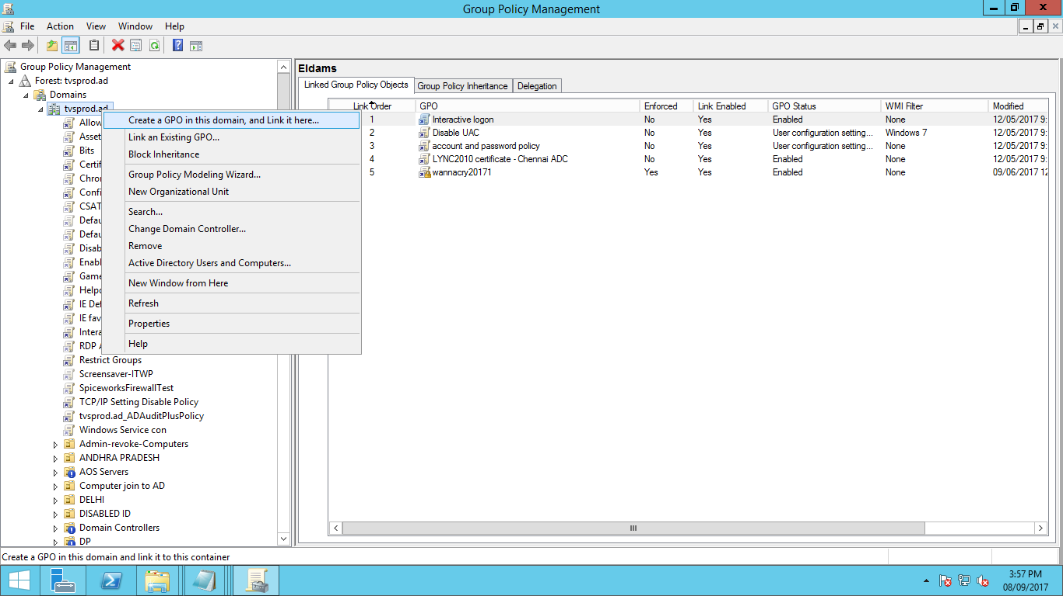

27.  In the New GPO dialog box, type **WSUS Policy  and then click OK…**

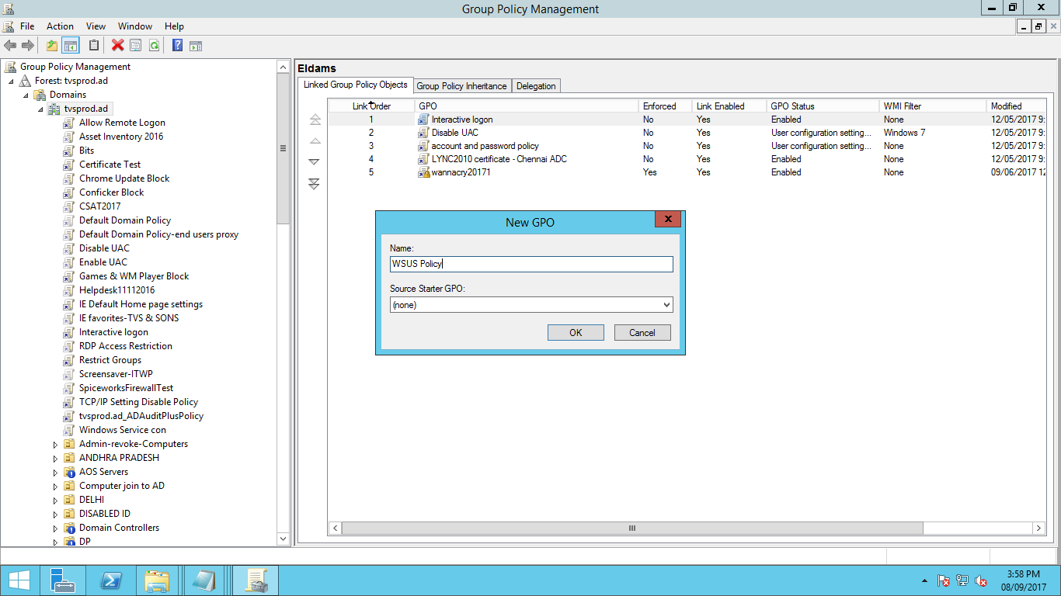

28. Next, **right-click WSUS Policy, and then click Edit…**

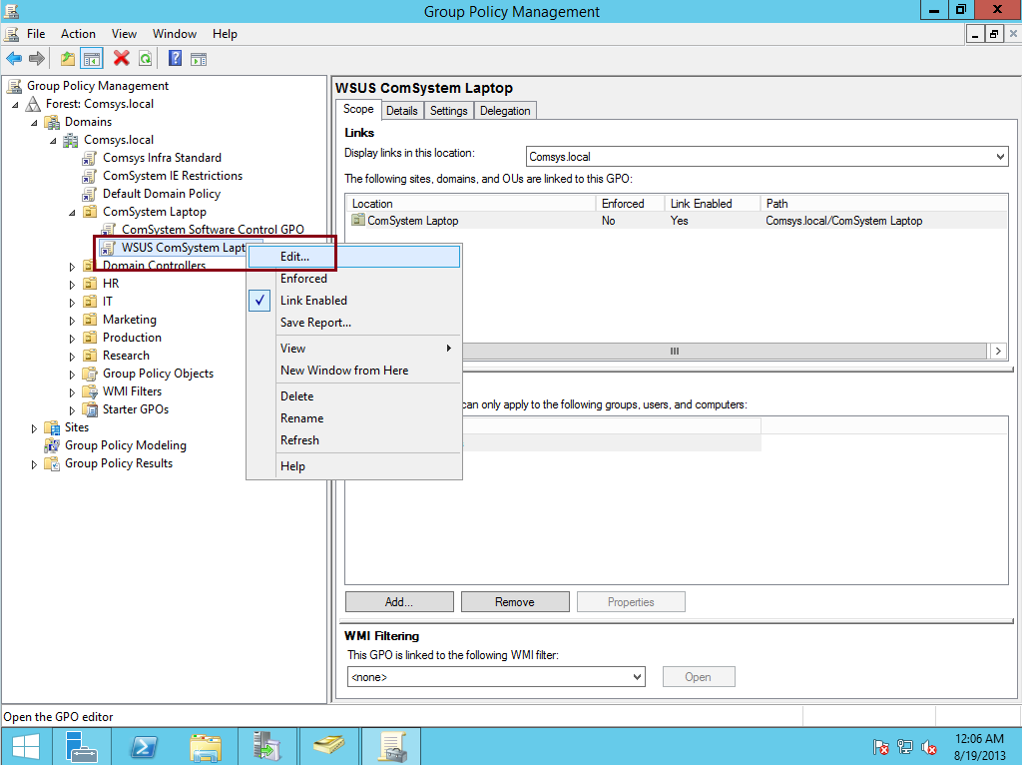

29. Next, in the Group Policy Management Editor, under **Computer Configuration, double-click Policies, double-click Administrative Templates, double-click Windows Components, and then click Windows Update…**

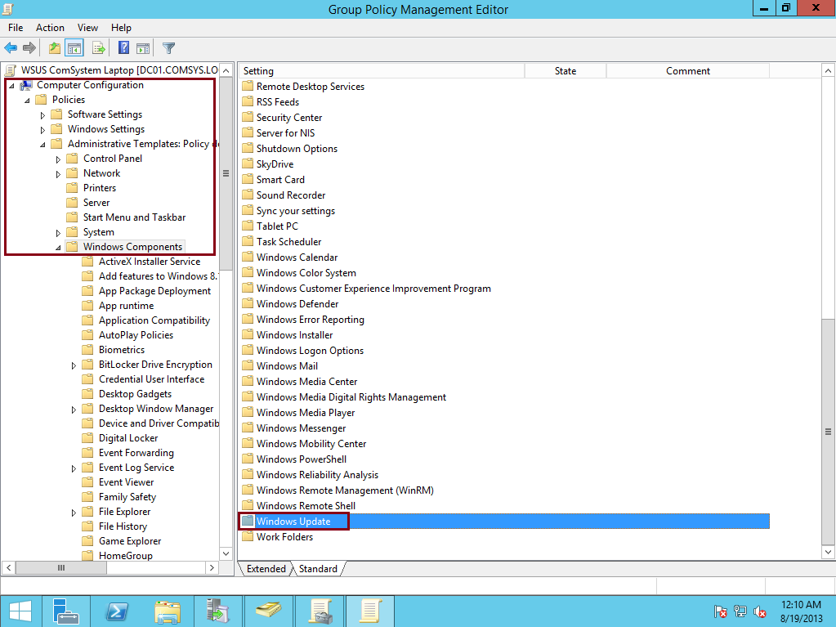

30. Next, in the Setting pane, double-click **Configure Automatic Updates, and then click the Enabled option, under Options, in the Configure automatic updating field, click and select 3 – Auto download and notify for install, and then click OK…**

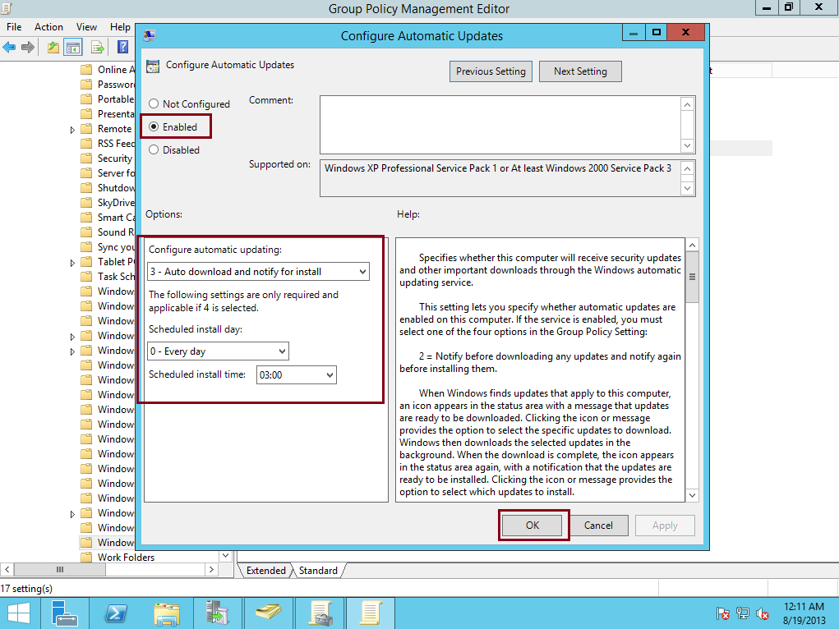

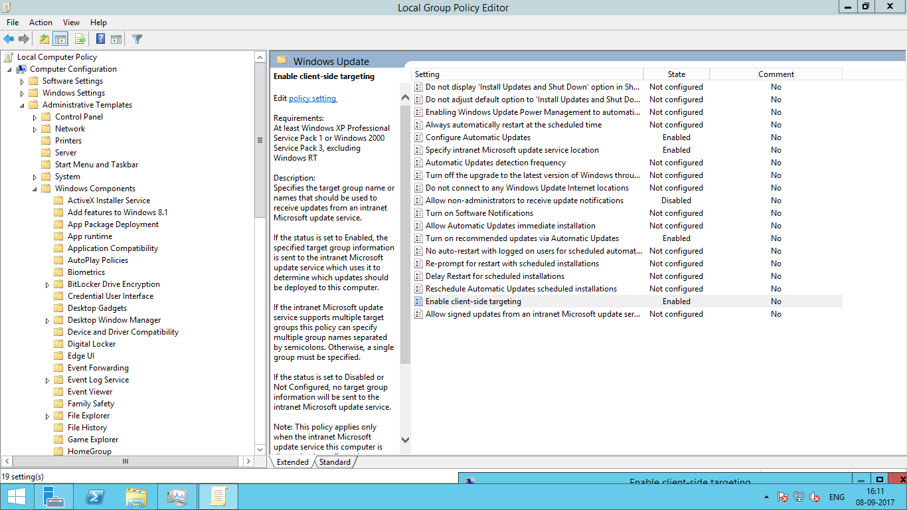

31.  In the Setting pane, double-click**Specify intranet Microsoft update service location, and then click the Enabled option, then in the Set the intranet update service for detecting updates and the Set the intranet statistics server text boxes, type**<http://tvs-inf-nsmon1.tvsprod.ad.ad:8530>**, and then click OK…**

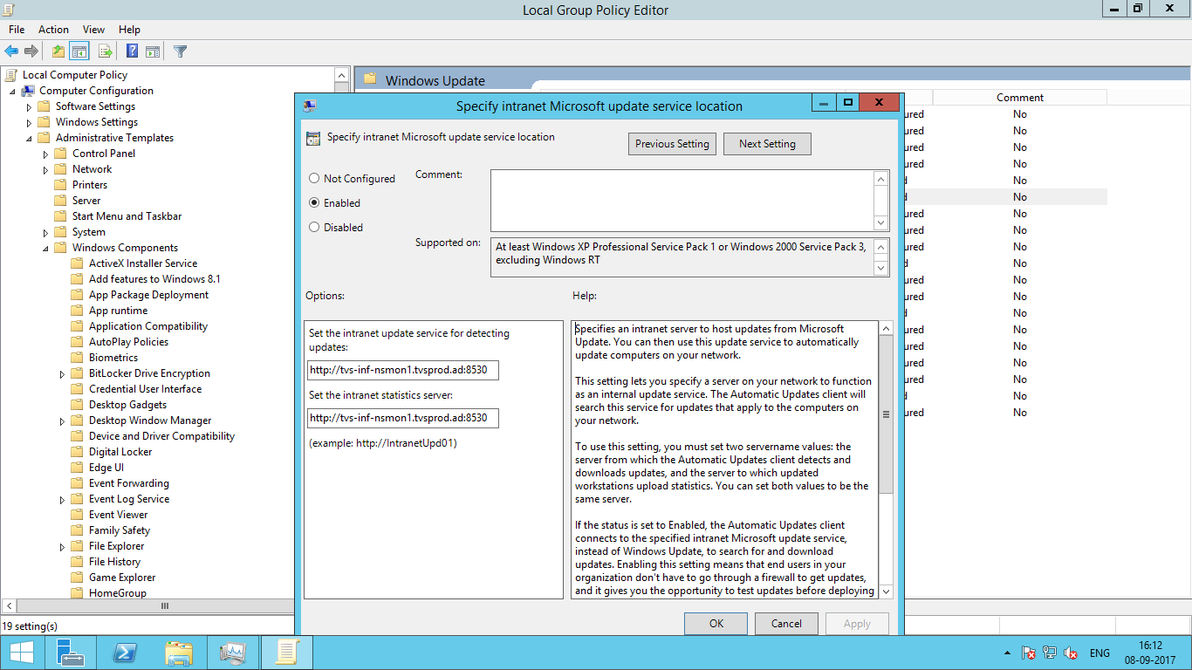

32.  In the Setting pane, double click **Enable client-side targeting, in the Enable client-side targeting dialog box, click the Enabled option, in the Target group name for this computer text box, type Phase1 and then click OK…**

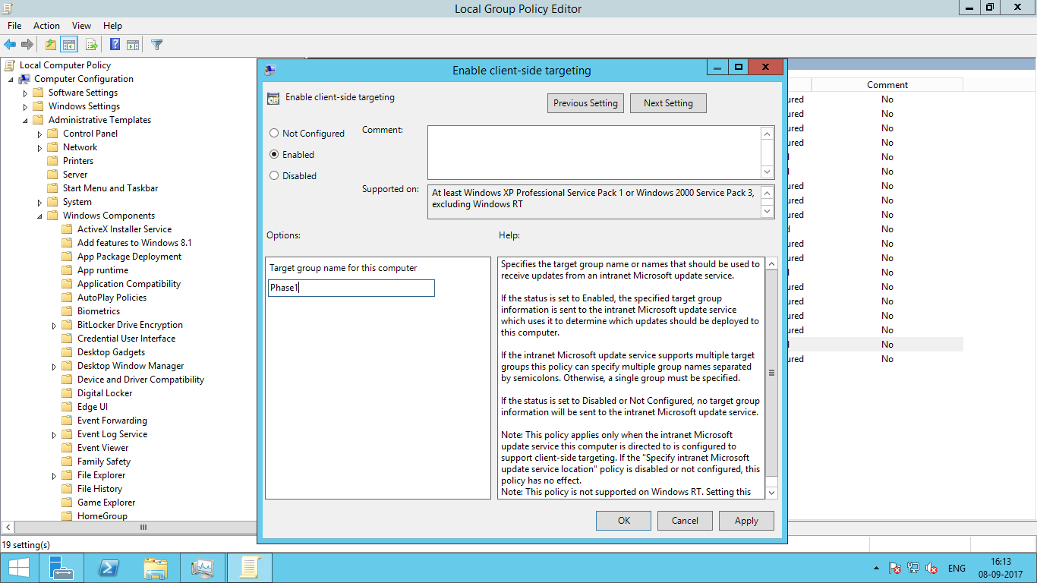

33. Next, we need to**Initialize the Windows Update by typing Wuauclt.exe/reportnow in the client server cmd…**

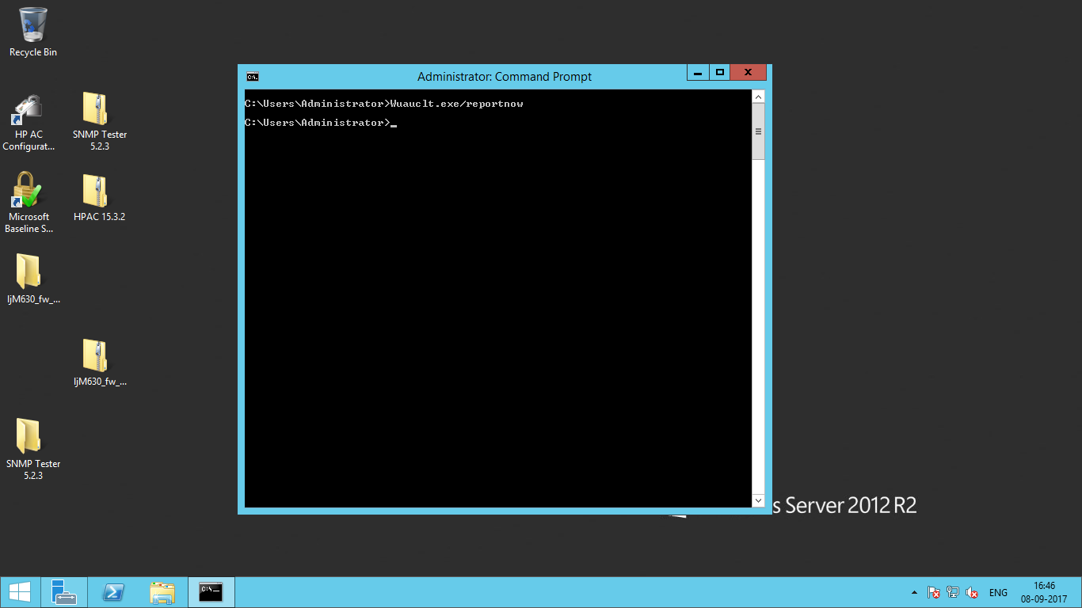

34. Next, we need to**initialize the Windows Update by typing Wuauclt.exe/ detectnow in the WSUS server cmd…**

Now Target server is started to report WSUS server.

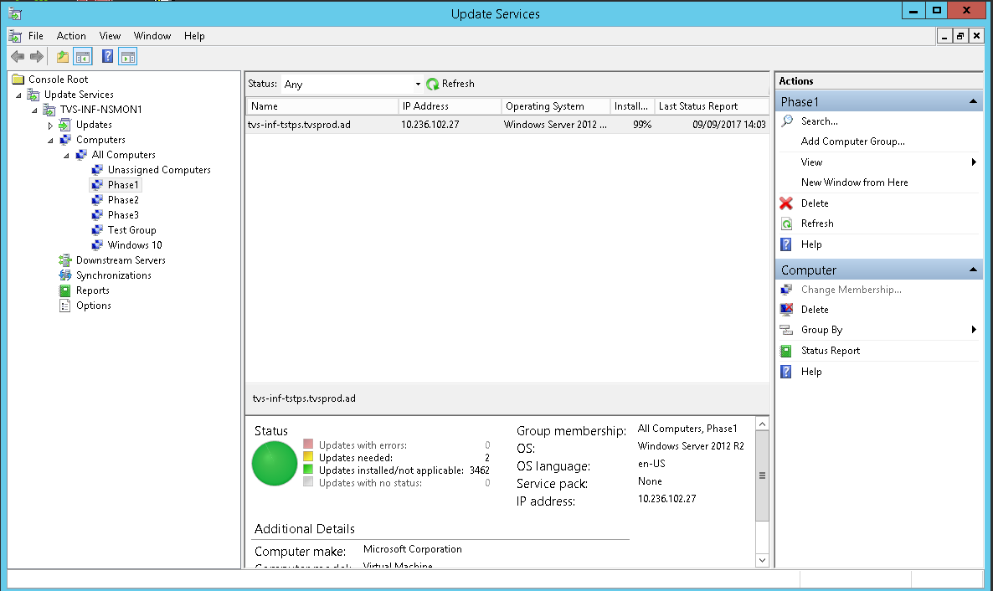

35. Next, we need to **Approve and at the same time deploy an Update to our client PC…**

In WSUS console, under **Updates, click Critical Updates, right click any updates you prefer for your client PC and then click Approve…**

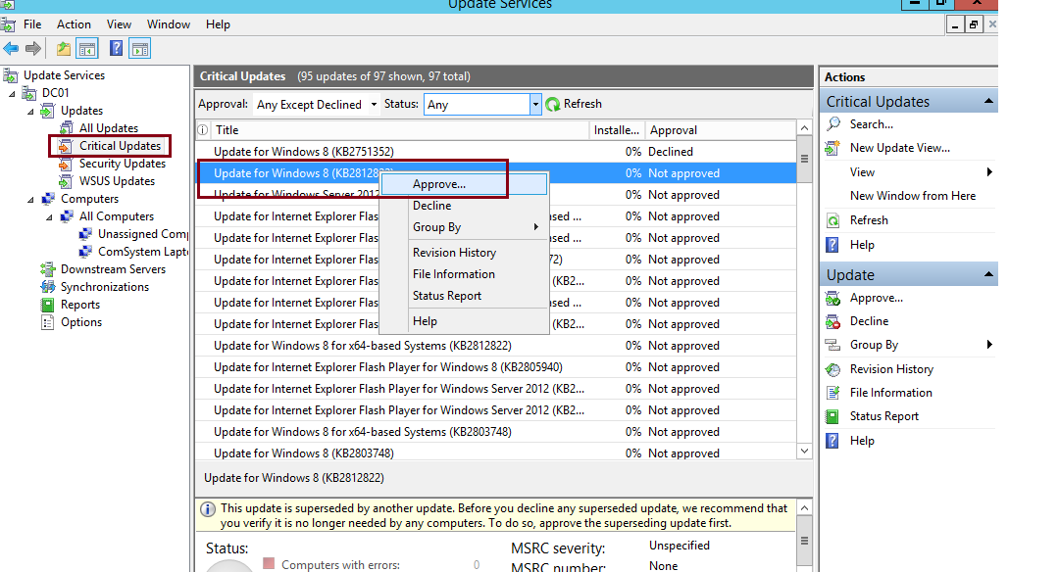

36.  In the Approve Updates window, in the Target server drop-down list box, select **Approved for Install…**

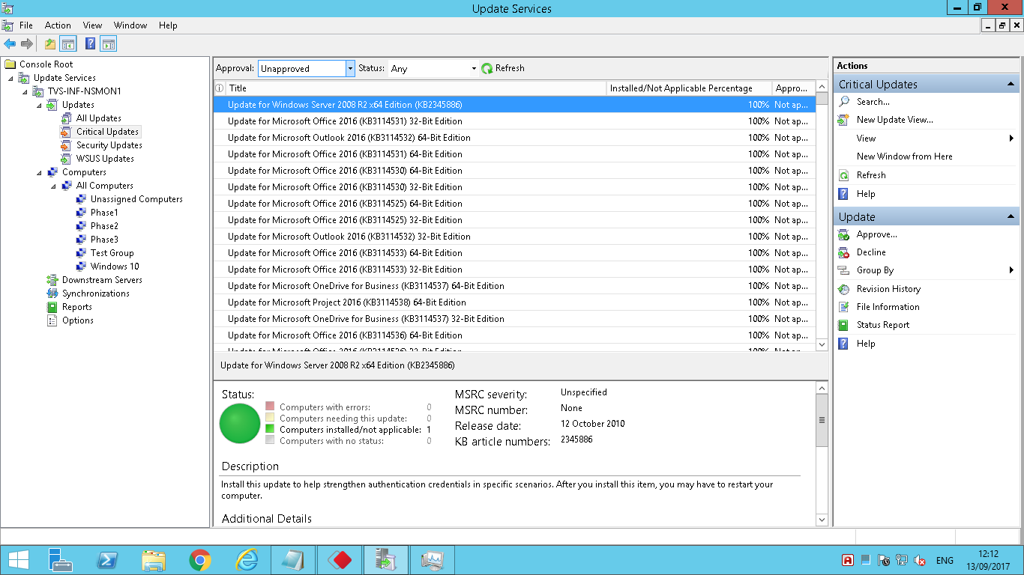

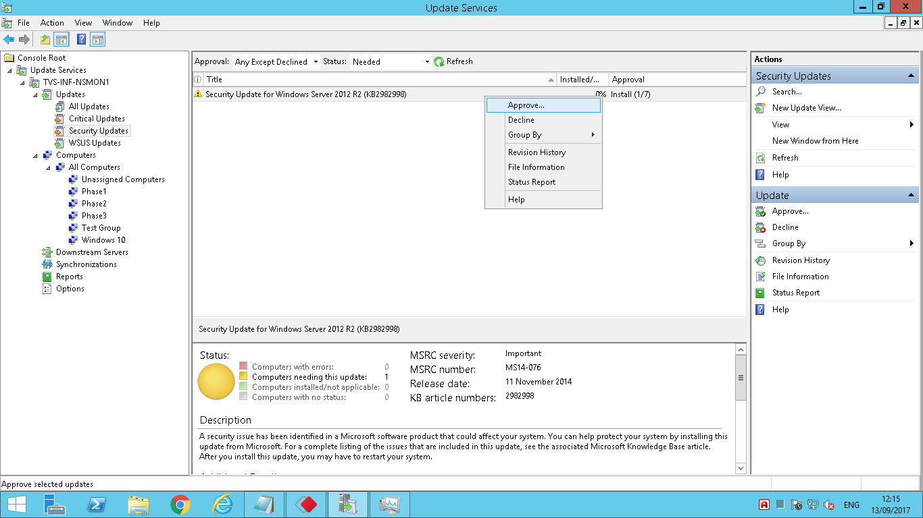

37. Next, Click OK and then click Close…

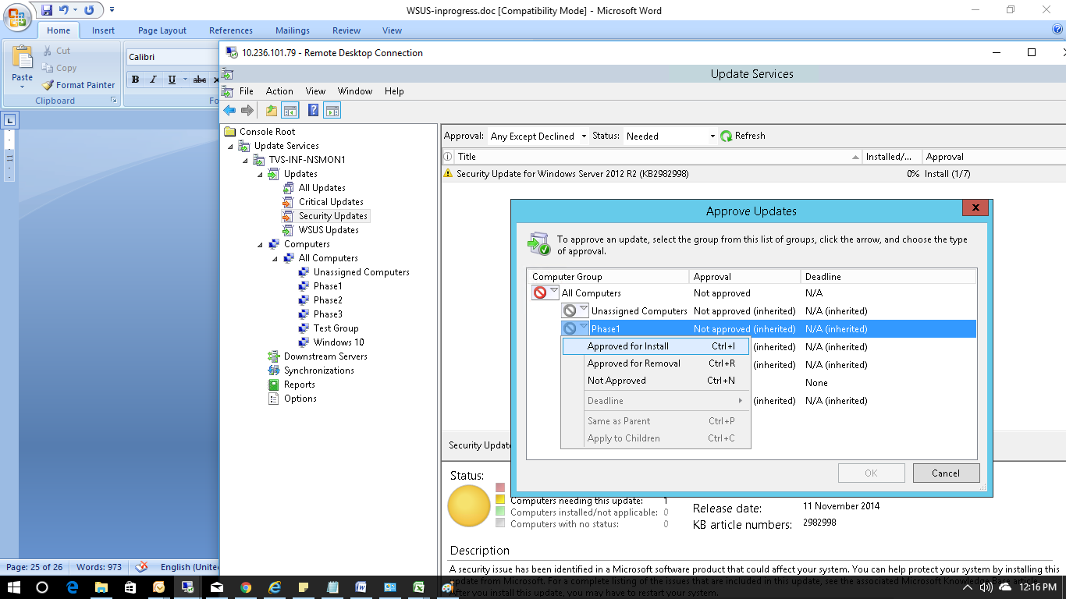

38. Now, to **deploy the selected updates**, on the Client PC, in the cmd type **Wuauclt.exe /detectnow…**

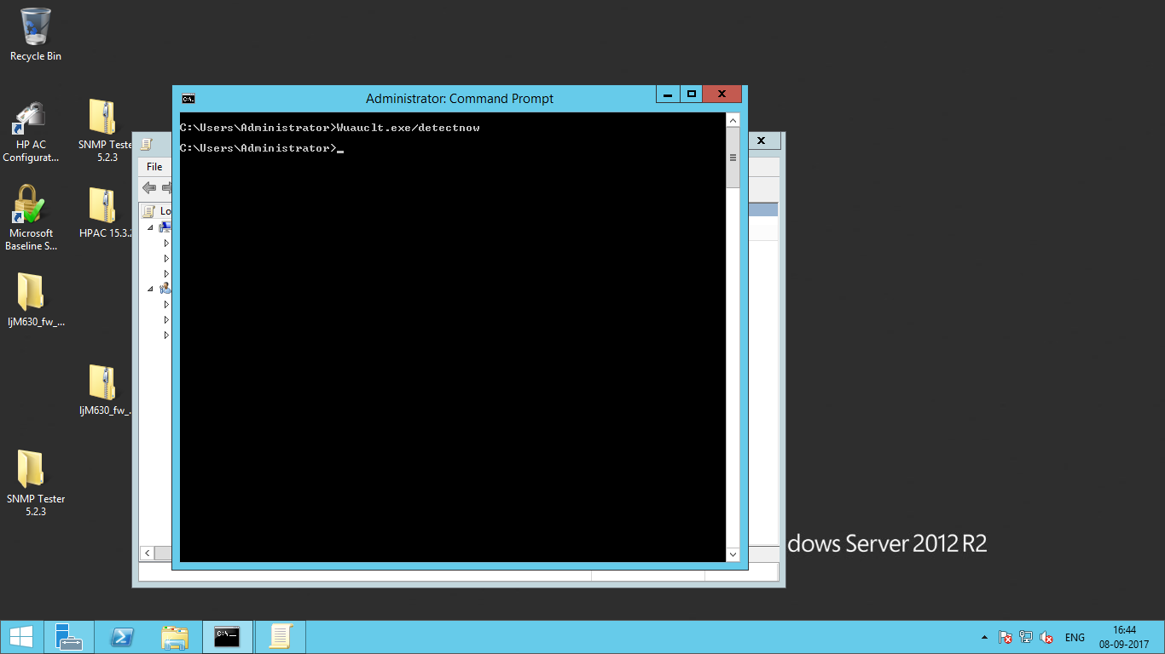

39. Before you confirm the client can receive the update from the WSUS Server, **return to WSUS Server and the on the WSUS console, on the Download Status, verify that the necessary / selected updates is finish downloading…**

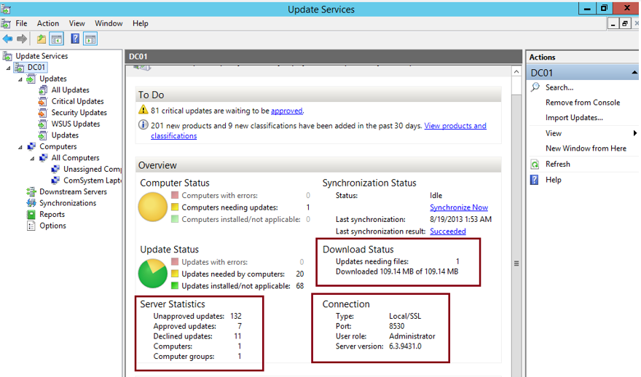

40. Next, Click Critical Updates, and the right panes, **verify that few updates is stated 100%…**

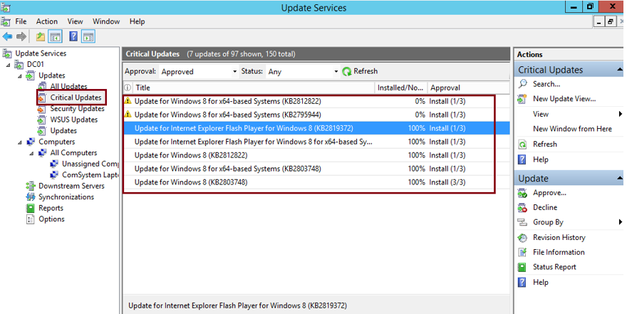

41. Now return to Client PC and open **Windows Update from Control Panel, you should notice update available for your client PC and you can proceed with installation…**

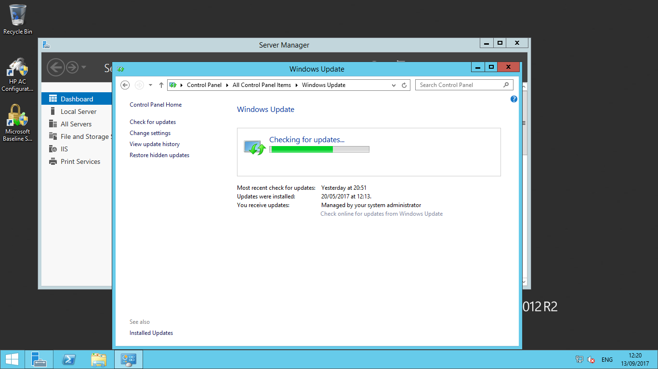

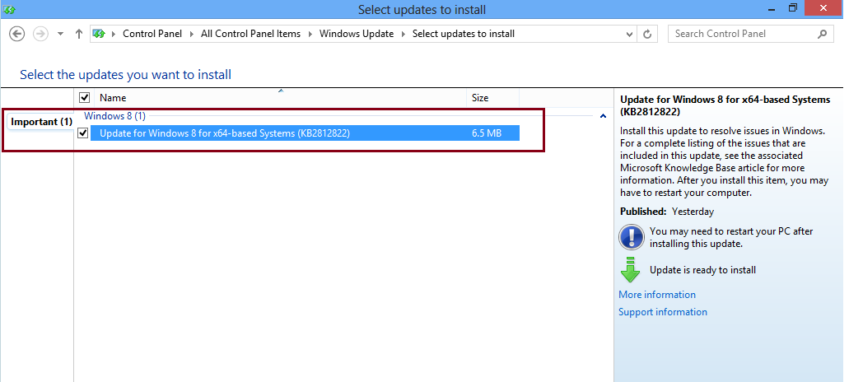

42. As mentioned in the previous steps we have to include the Test servers in Test Phase ,production servers in Phase1,Phase2,Phase3 and we have to install the patches in the servers.

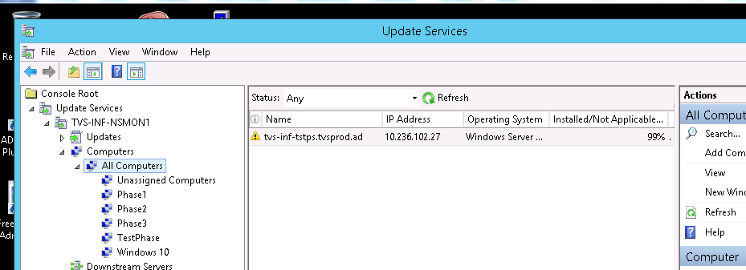

43. Once patch installation has been completed, kindly restart the server during the down time.

44. To revert back the patch, Right click on the patch and click on Approve.

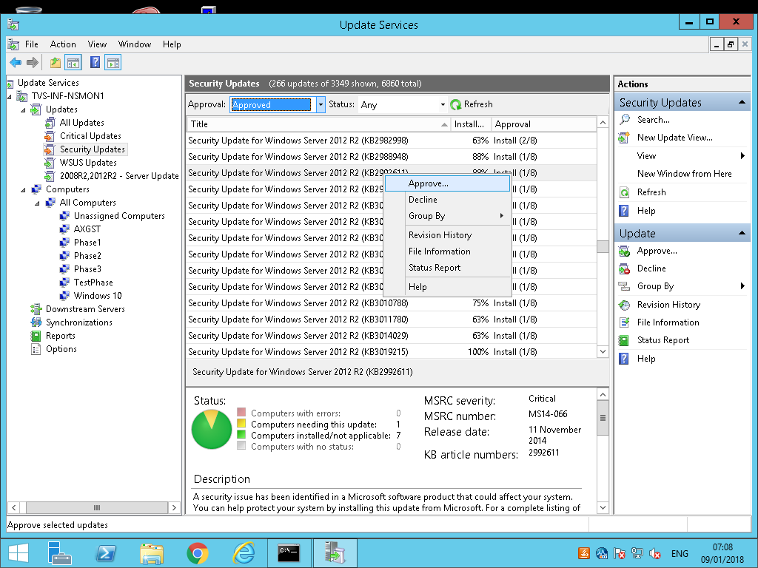

Select the computer group from where we have to remove the Patch then select “Approve for removal”

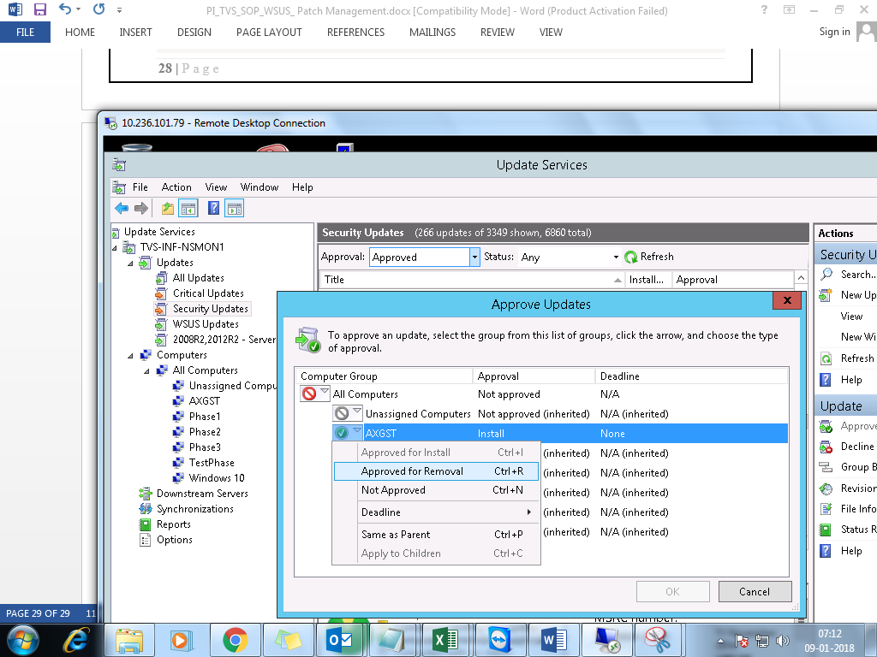

The particular patch will be removed from all the servers in the group.

Thanks for reading the document.